**（2.1） Sets**

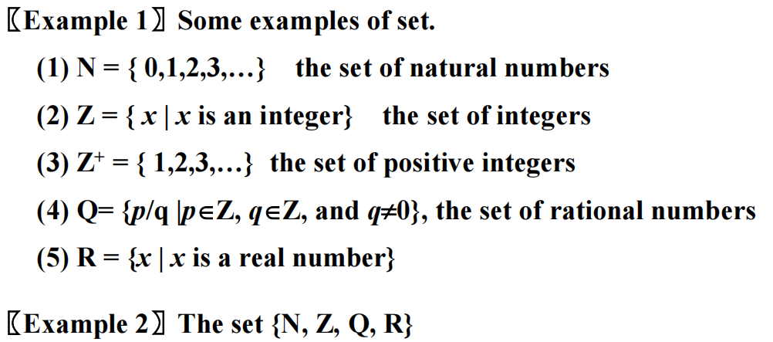

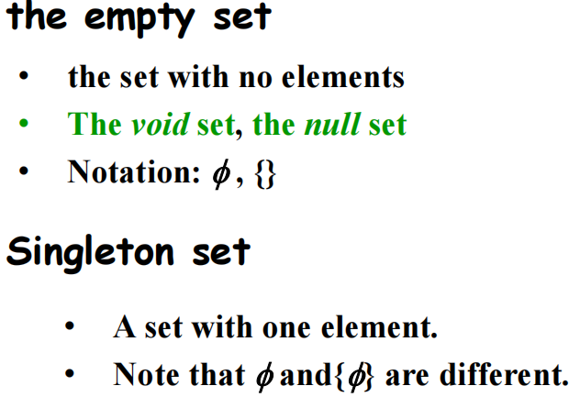

• 只有空集这一个元素的集合也是单元素集

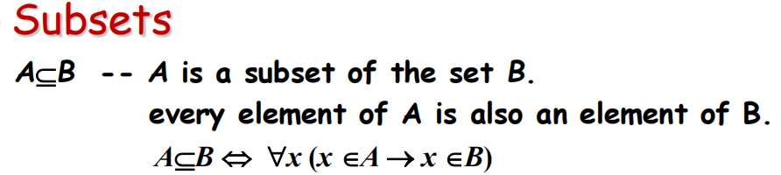

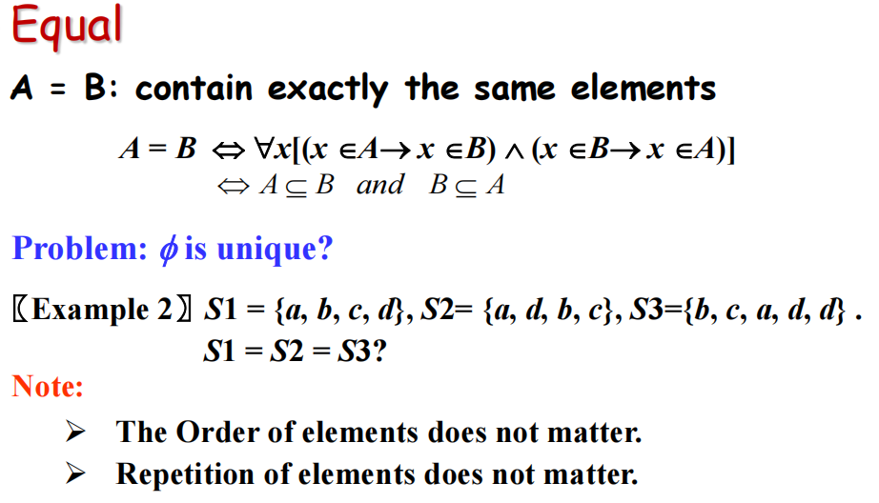

Proper subset （真子集）

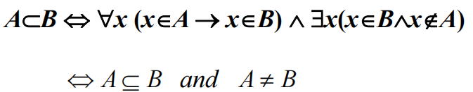

The Size of a Set （集合的大小）

**【Definition 】 Let S be a set. If there are exactly n distinct elements in S where n is a nonnegative integer, we say that S is a finite set and that n is the cardinality（基数） of S.**

**Notation:**

**∣*S*∣---- the cardinality of *S （集合基数的表示符号）***

**【Definition 】A set is said to be infinite（无限集） if it is not finite.**

Power Sets（幂集）

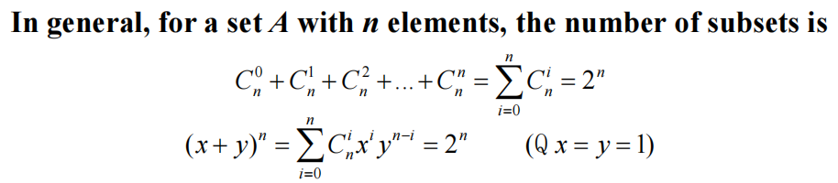

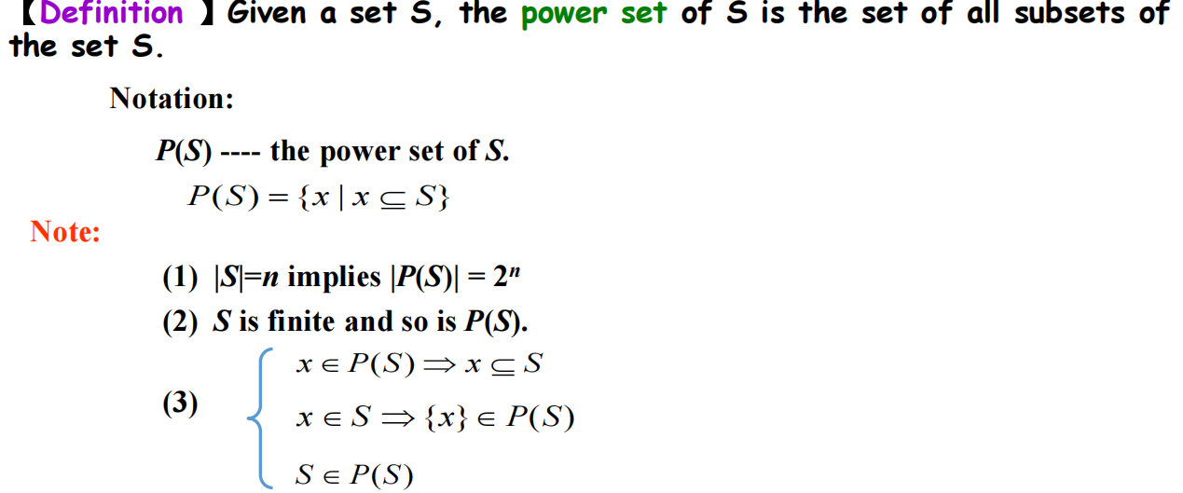

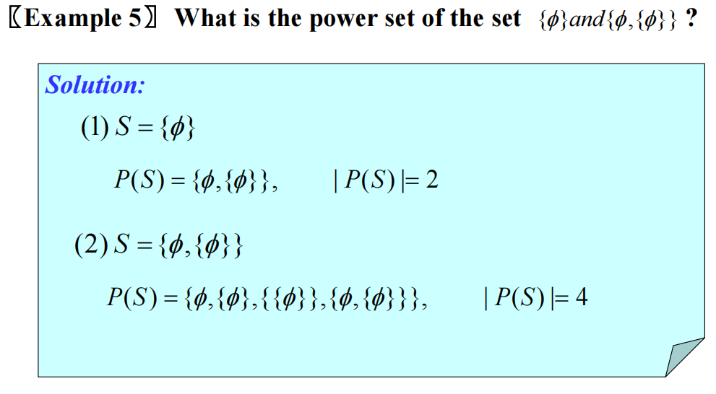

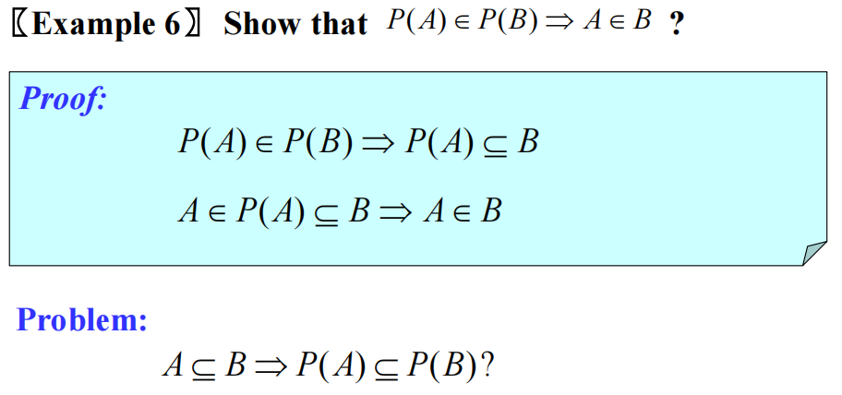

Cartesian Products （笛卡儿积）

**【Definition 】The ordered n-tuple (a1,a2,…,an) is the ordered collection that has a1 as its first element, a2 as its second element, … , and an as its nth element.**

**(*a*1, *a*2, …,*an*) =(*b*1, *b*2, …, *bn*) ⇔ *ai* = *bi* (*i*=1,2,…, *n*)**

**In particular, 2-tuples are called ordered pairs（有序对）*.***

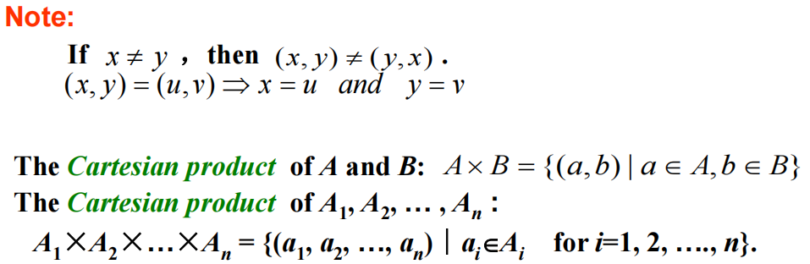

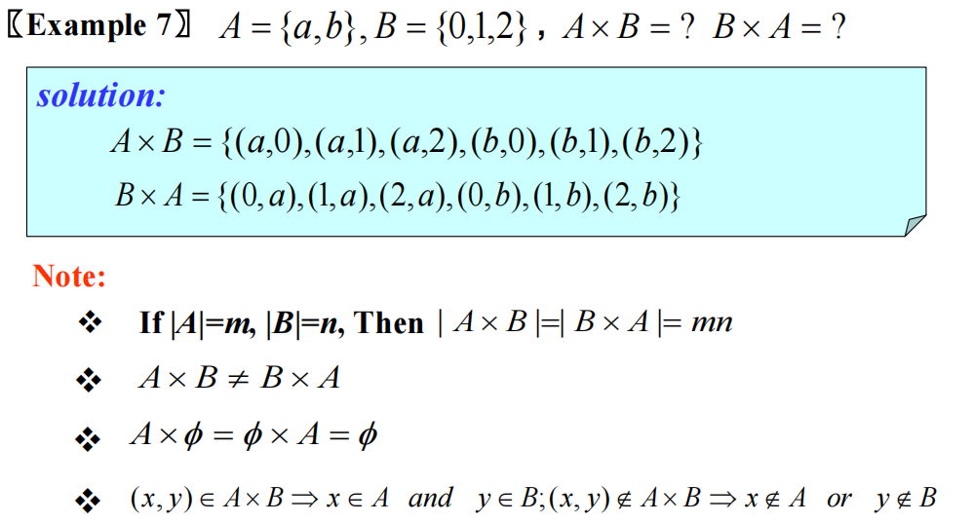

Using Set Notation with Quantifiers

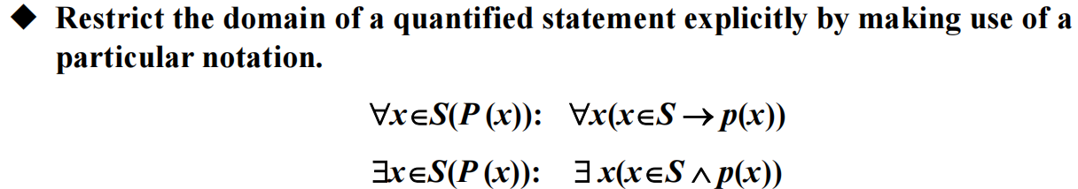

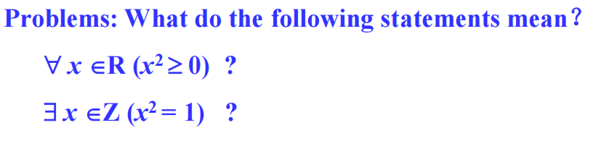

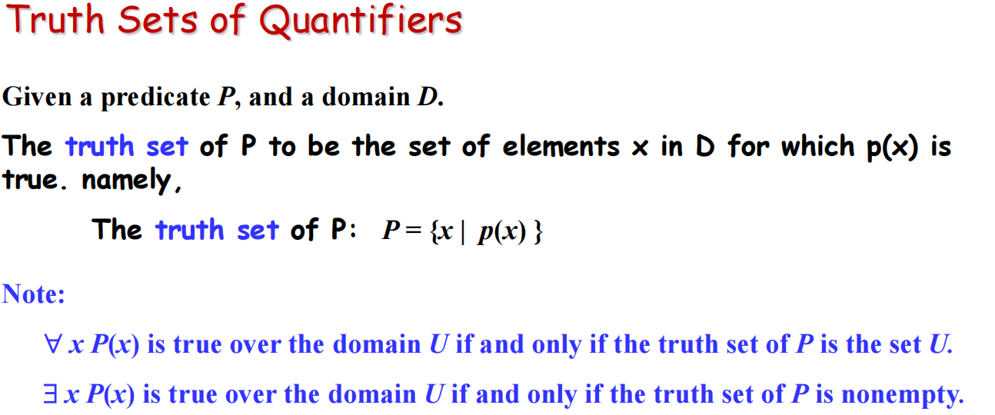

**（2.2） Set Operations**

Union（并集）

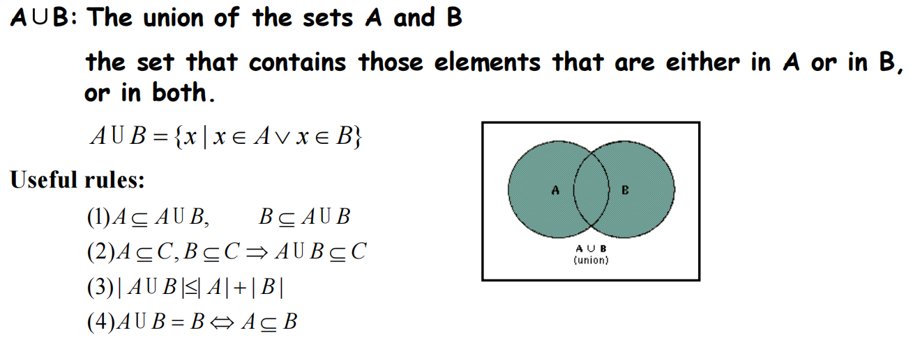

Intersection（交集）

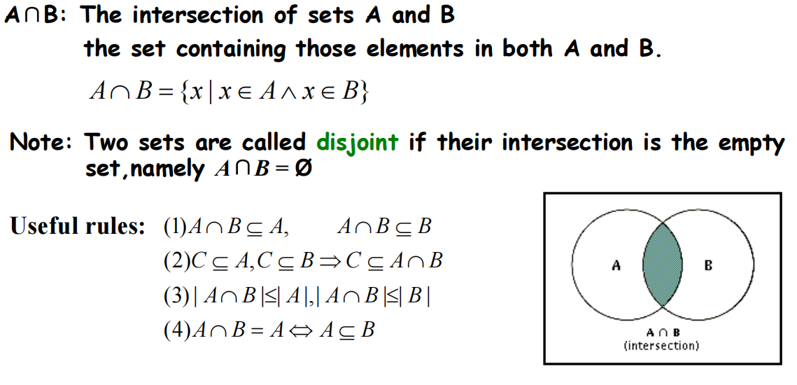

Complement （补集）

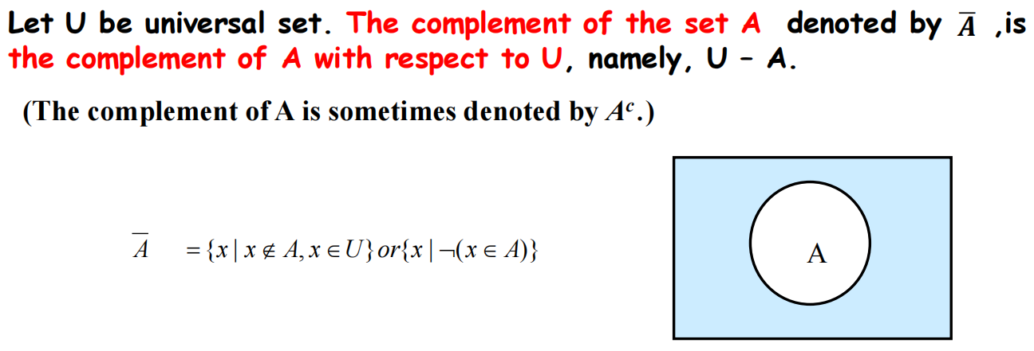

Difference（差集）

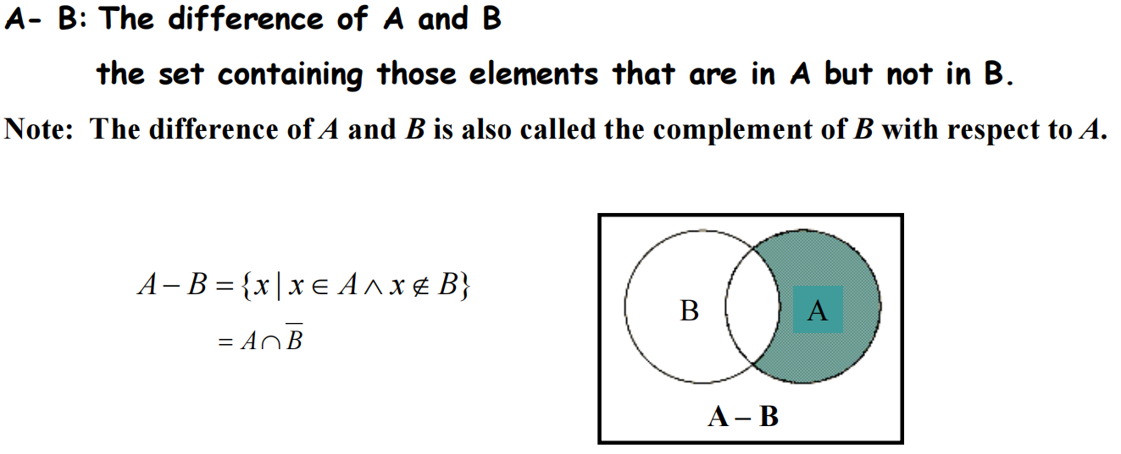

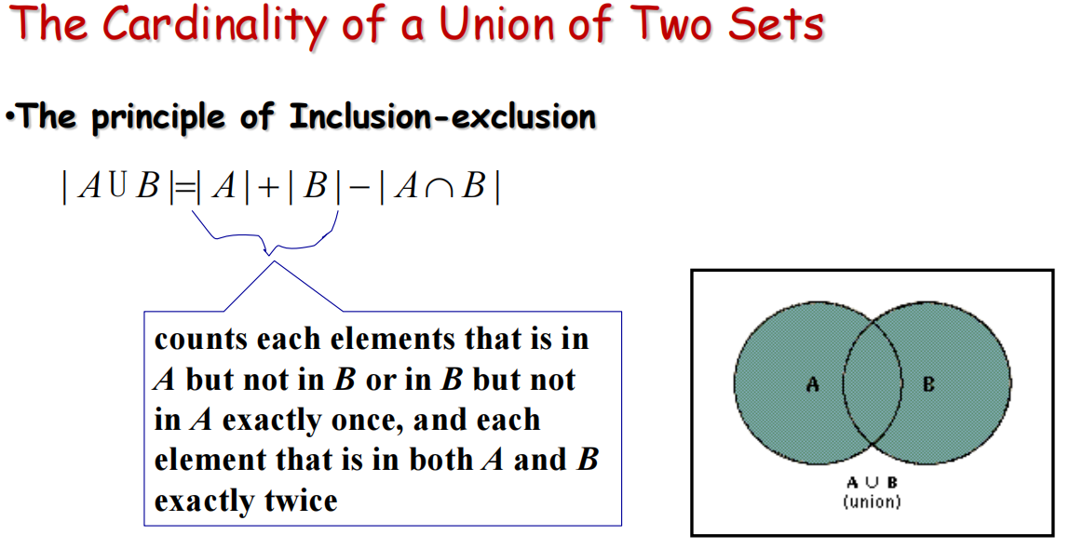

Symmetric difference （对称差）

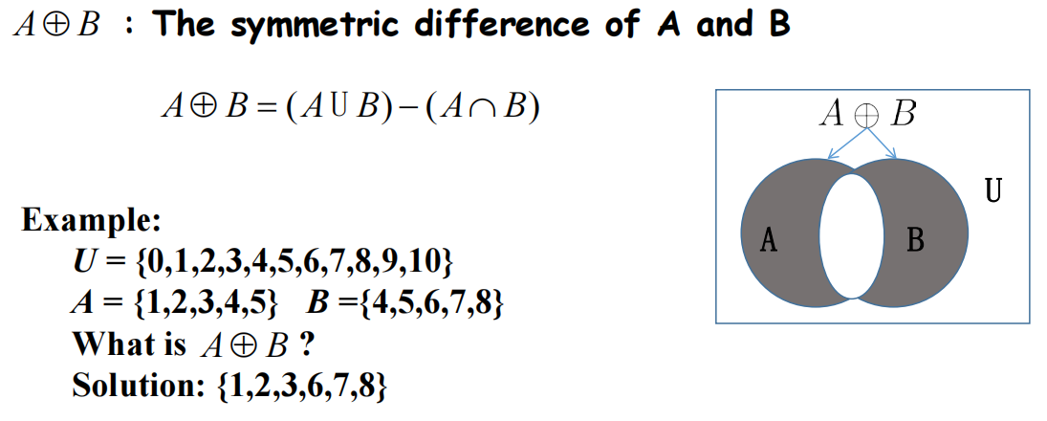

Set Identities （集合等式）

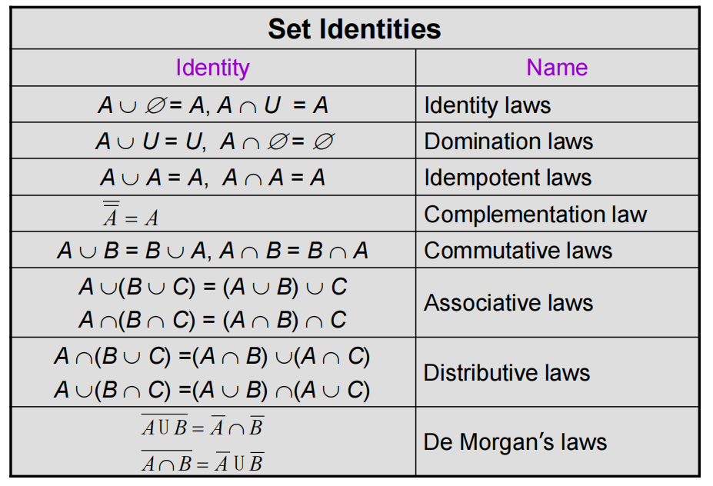

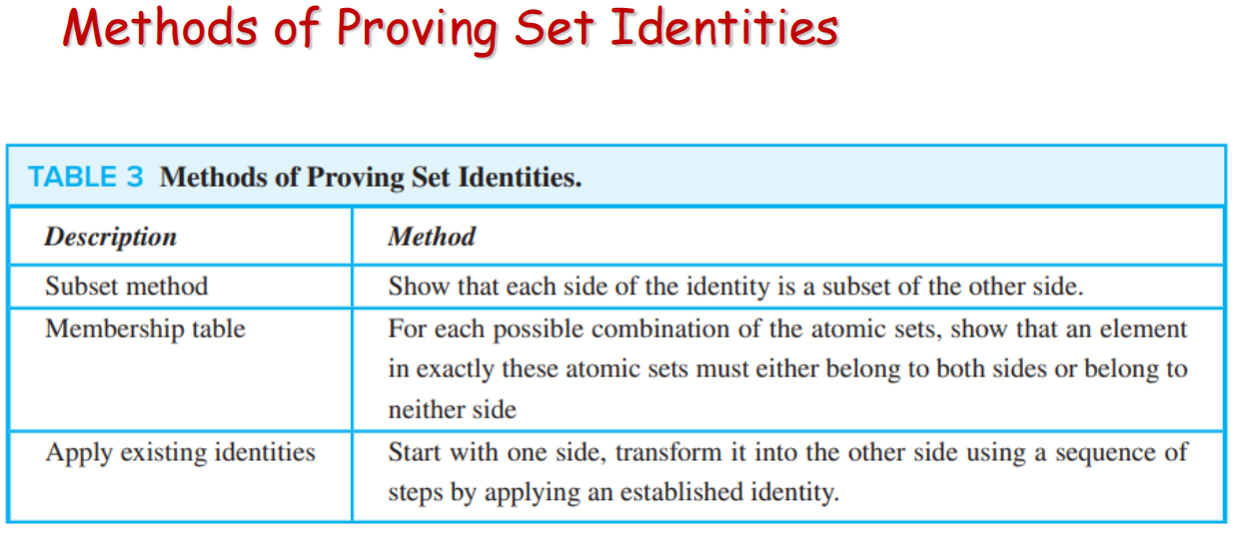

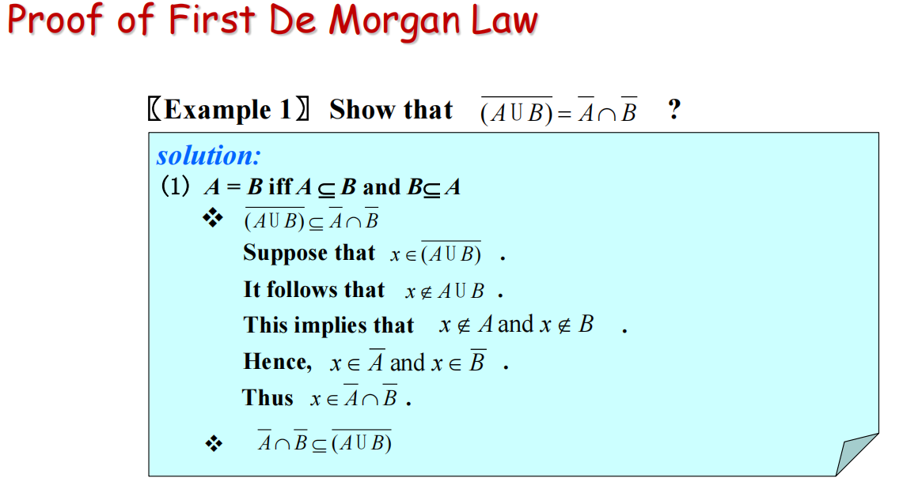

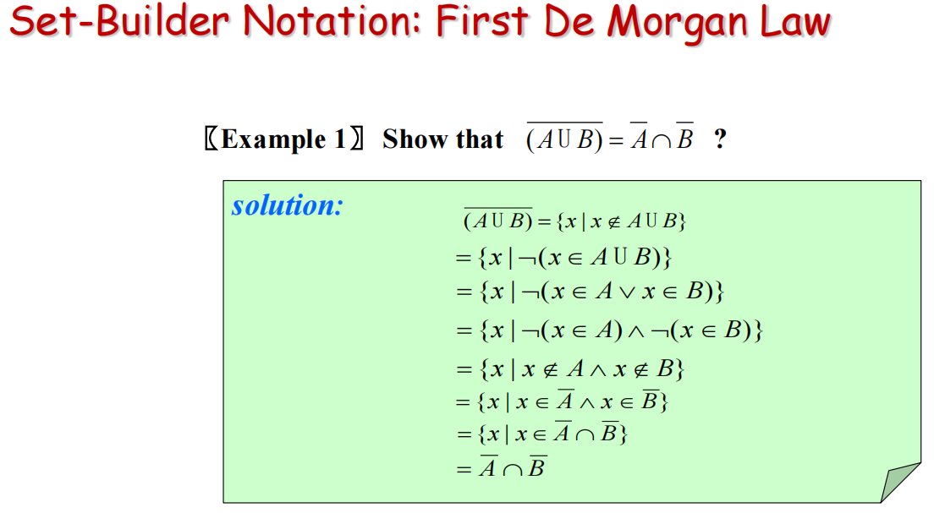

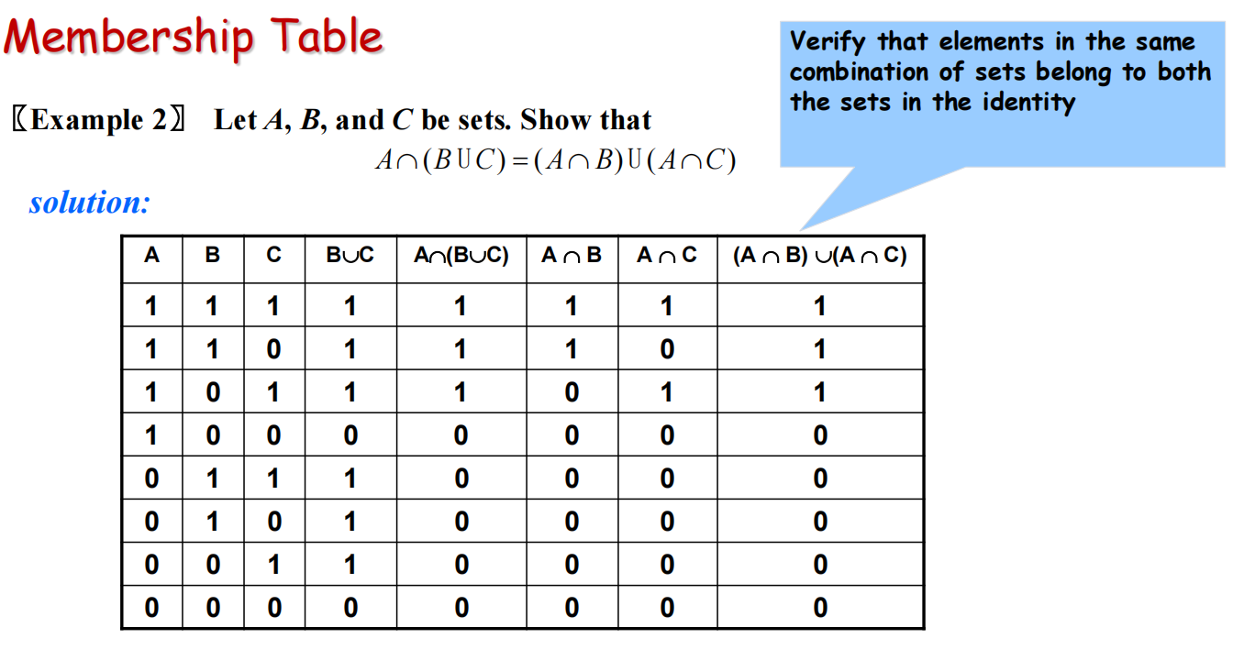

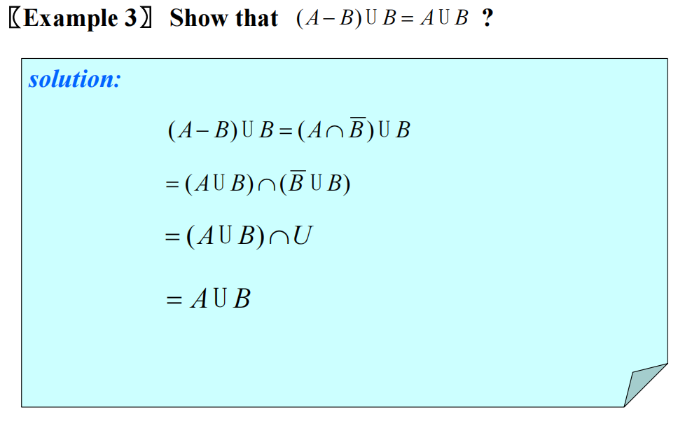

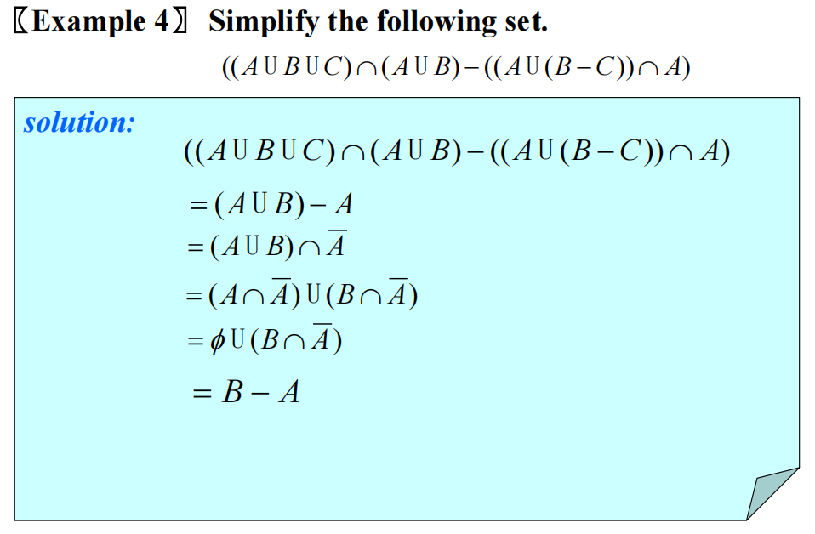

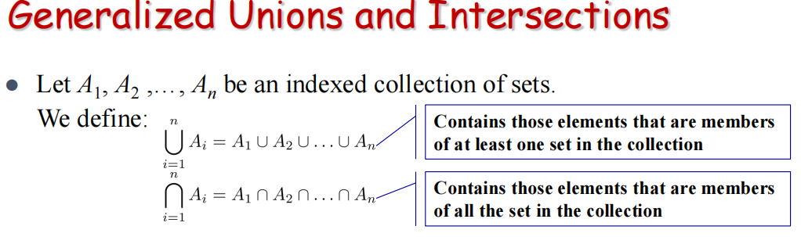

These are **well defined（严格定义）**, since union and intersection are associative

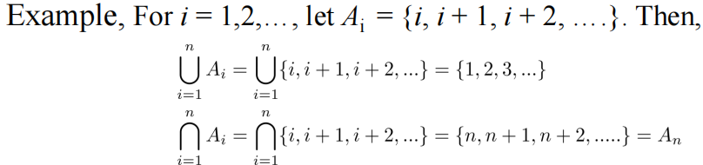

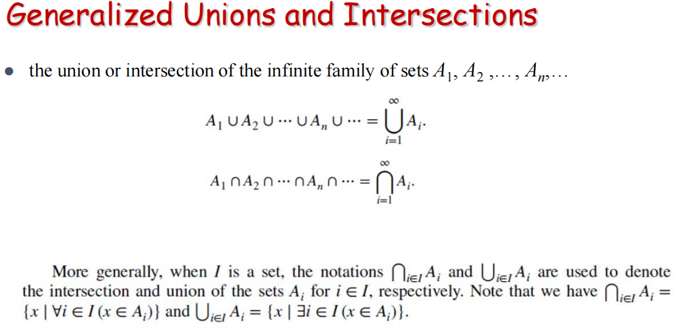

**（2.3）Functions**

Functions

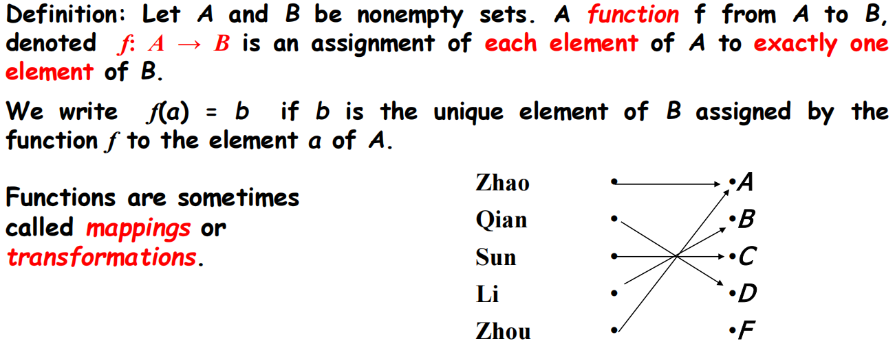

***Mappings/transformations(映射)***

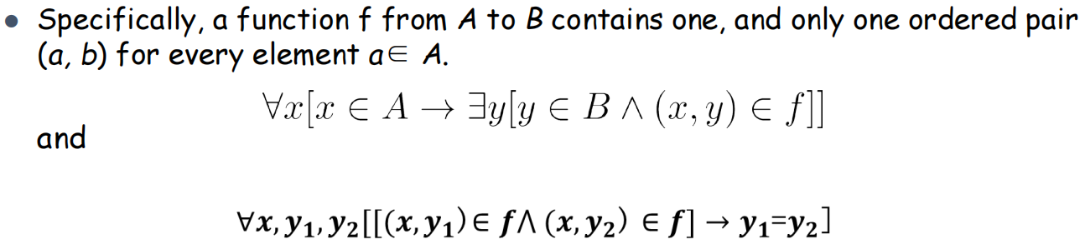

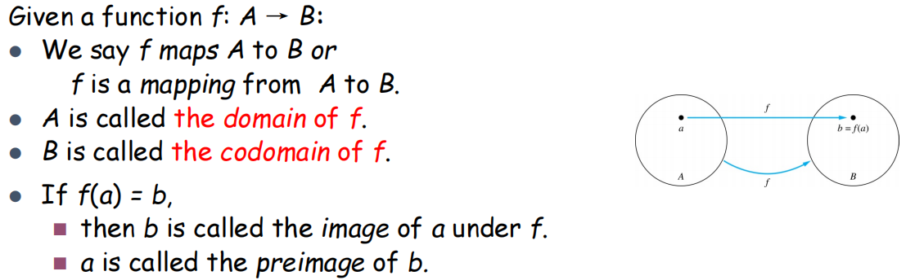

*Codomain(伴域)*

● The range of *f （值域）*is the set of all images of points（像的集合） in **A** under *f*. We denote it by *f*(*A*).

*（值域是伴域的子集，见下图）*

● Two functions are *equal* when they have the same domain, the same codomain and map each element of the domain to the same element of the codomain.

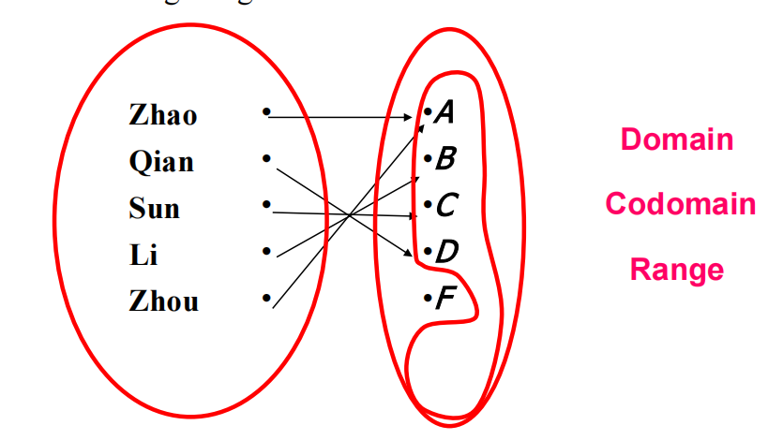

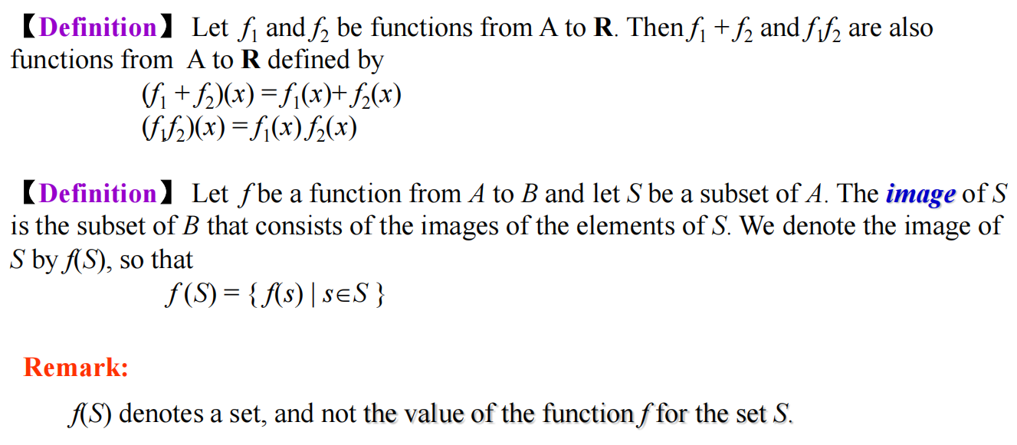

One-to-one Functions（单射）

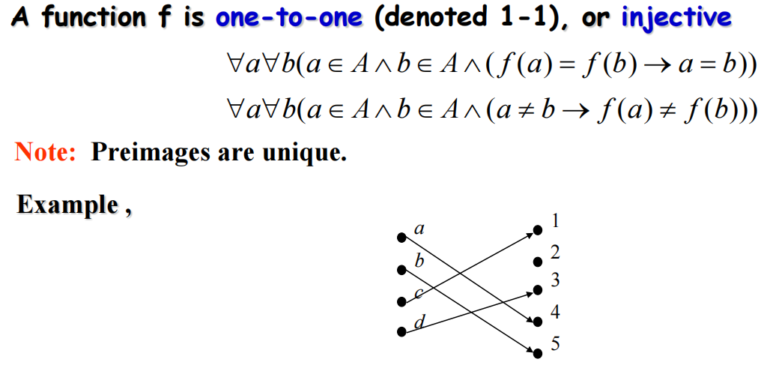

Onto Functions（满射）

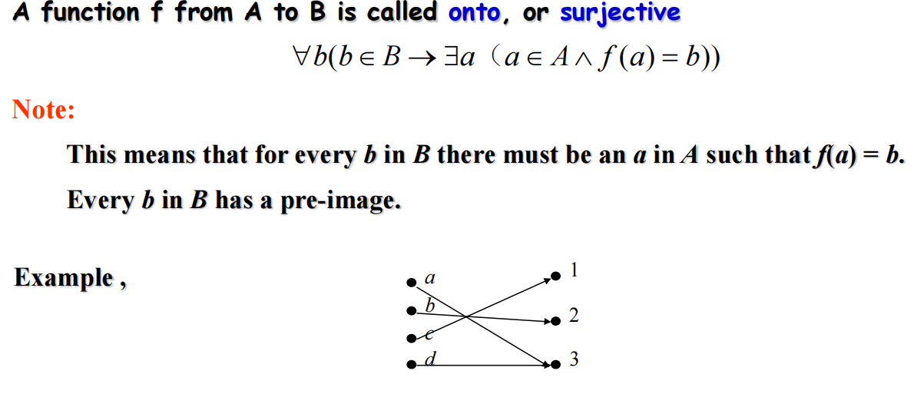

One-to-one Correspondence Functions（双射）

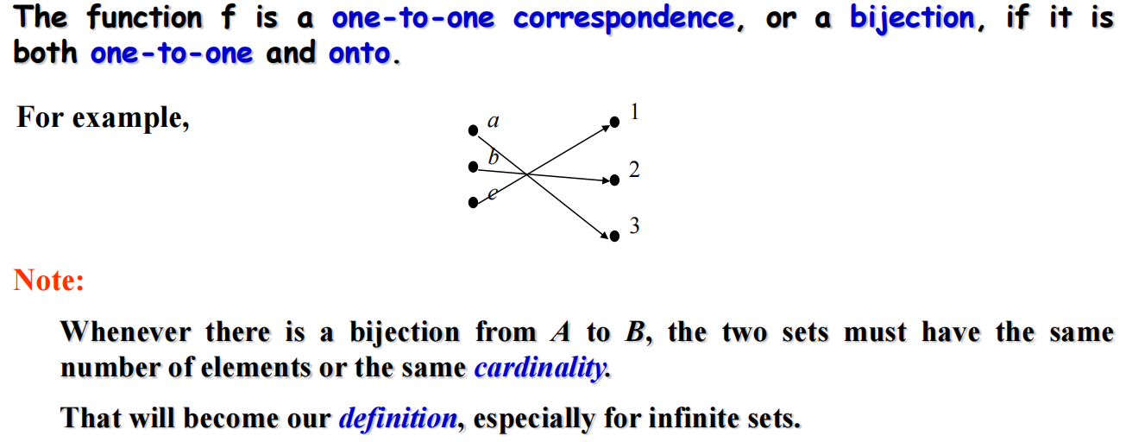

**Preimage（原像）cardinality（基数）**

**Injective/one-to-one（单射）**

**Surjective/onto（满射）**

**Bijection/one-to-one correspondence（双射）**

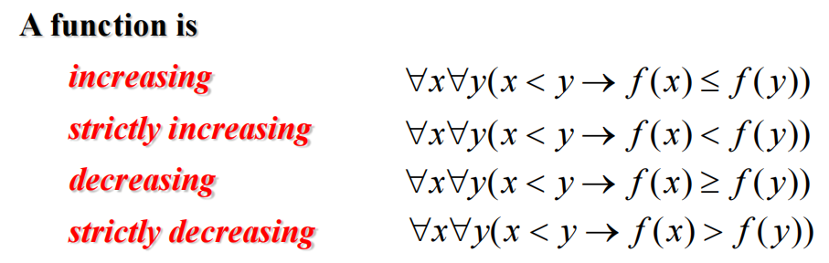

Inverse Functions （逆函数）

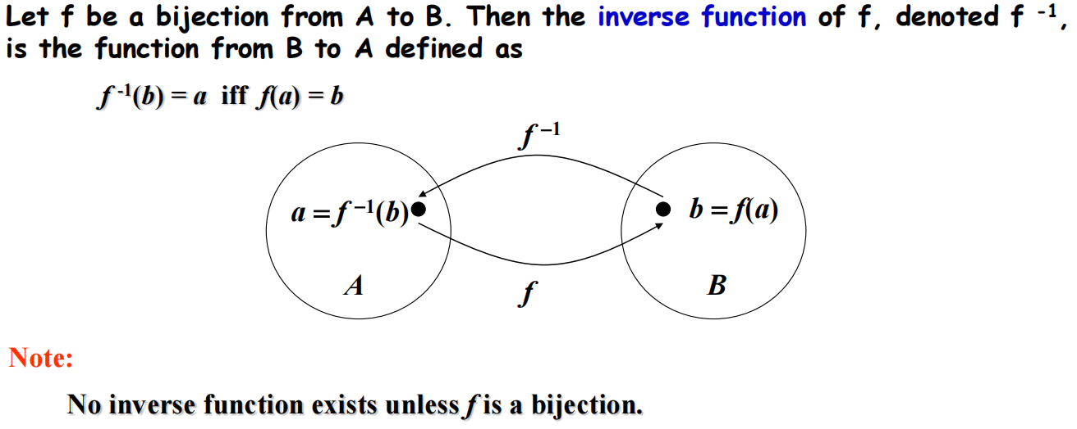

The Graphs of Functions （函数的图像）

**Let *f* be a function from the set *A* to the set *B*. The graph of the function *f* is the set of ordered pairs（有序对）**

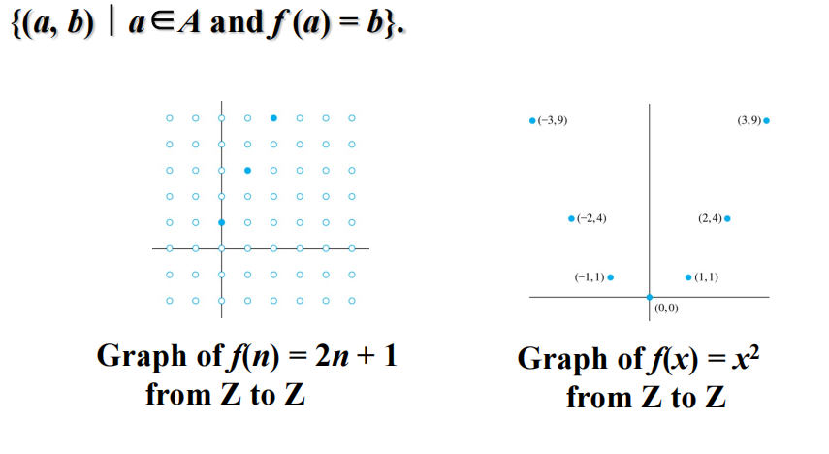

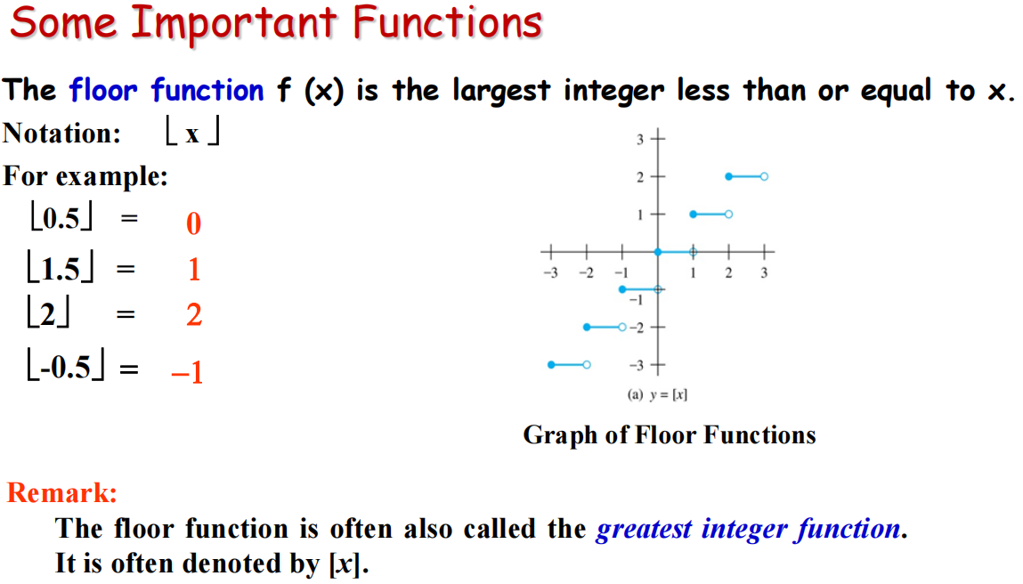

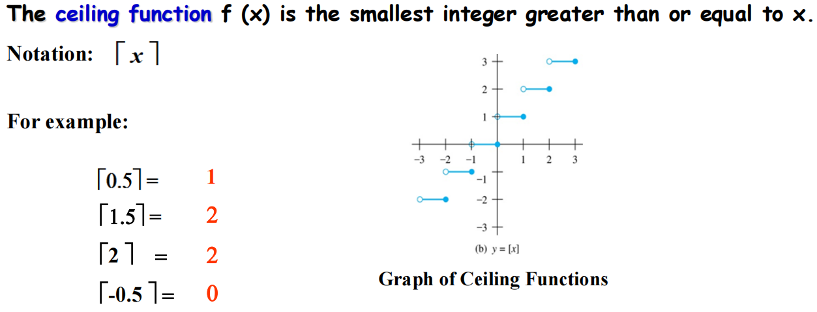



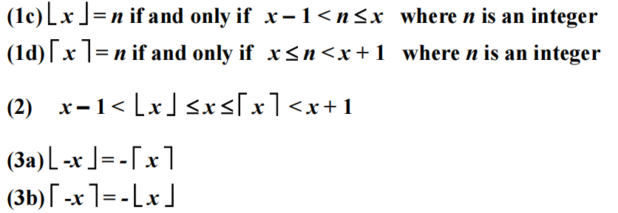

**对底函数和顶函数相关题目的证明方法**

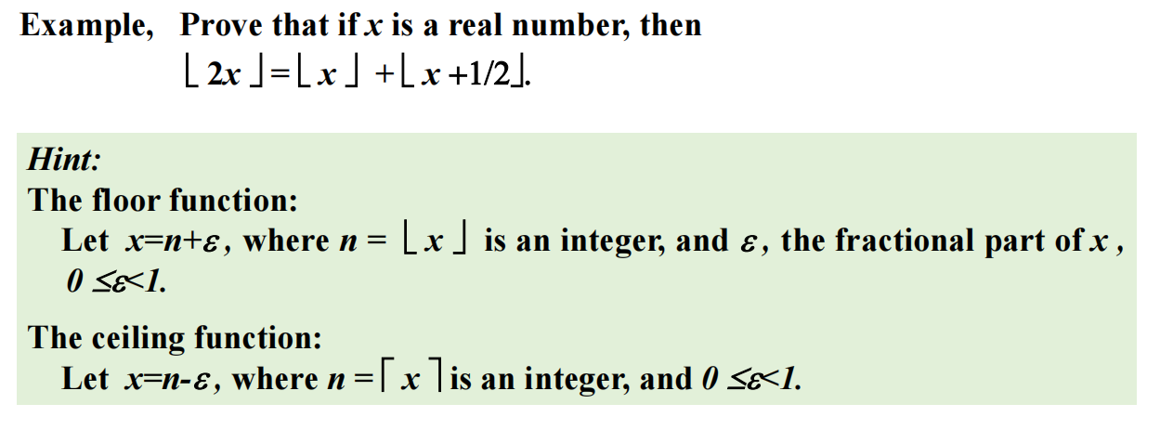

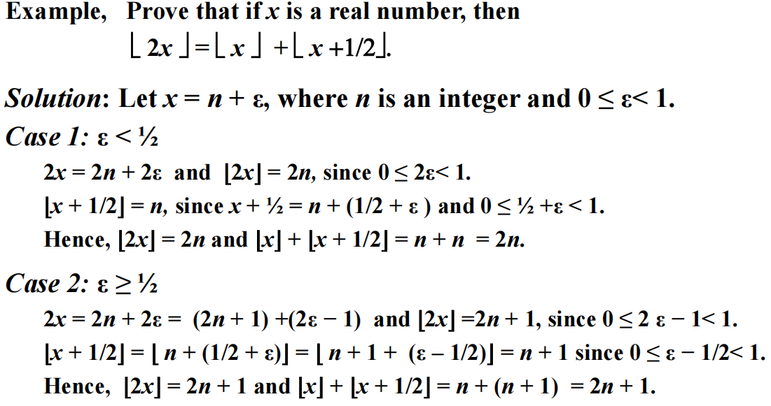

**（2.4）Sequences and Summations（序列和求和）**

*common ratio r（公比r）、common difference d （公差d）*

• The ***empty string*** is represented by *λ（空的字符串，空串）*

**Recurrence Relations（递推关系）**

• A sequence is called a ***solution*** of a recurrence relation if its terms

satisfy the recurrence relation.

• The ***initial conditions （初始条件）***for a sequence specify the terms that precede the first term where the recurrence relation takes effect.

**（2.5）Cardinality of Sets**

**（容斥原理）**

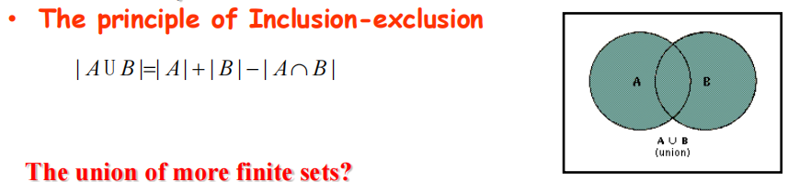

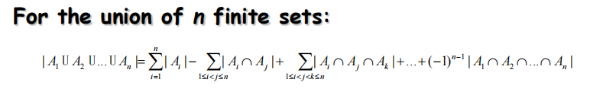

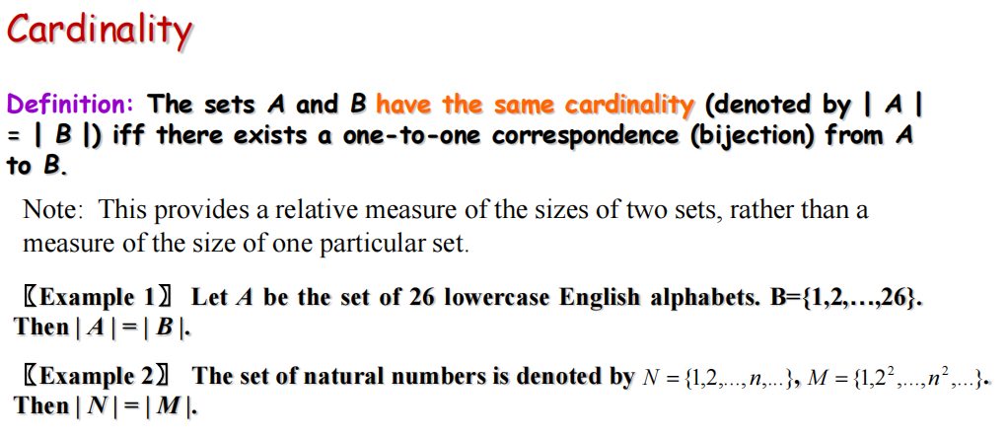

**Definition: If there is a one-to-one（一对一） function form *A* to *B*, the cardinality of *A* is less than or the same as cardinality of *B* (|*A*|≤|*B*|).**

**When |*A*|≤|*B*| and *A* and *B* have different cardinality, we say that the cardinality of *A* is less than the cardinality of *B* and we write |*A*|<|*B*| .**

Countable Sets（可数集合）

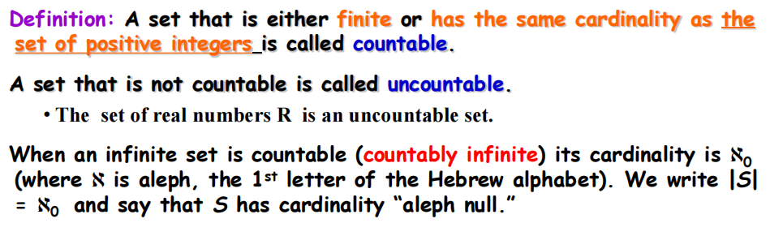

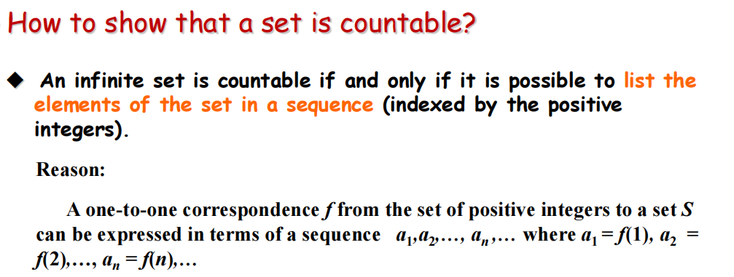

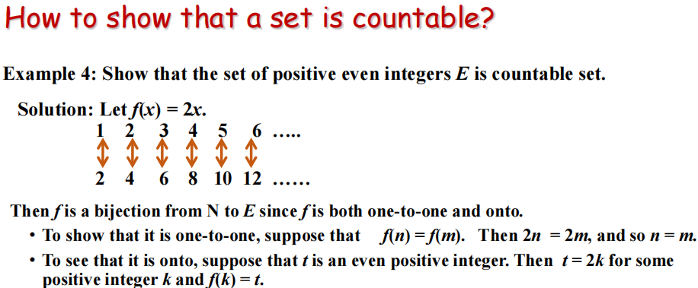

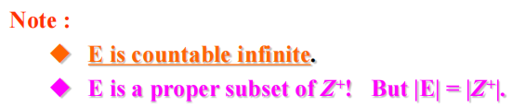

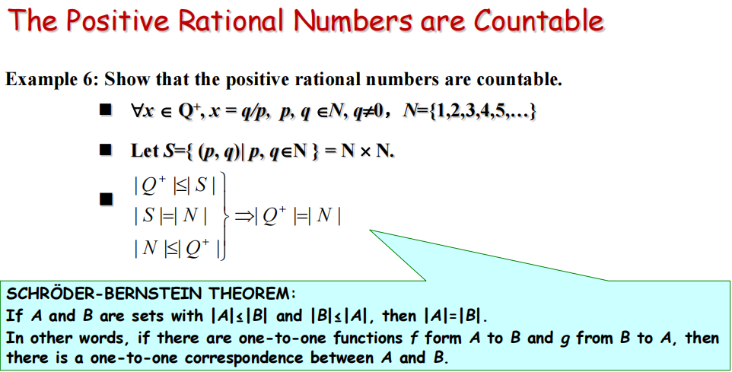

**Proof:**

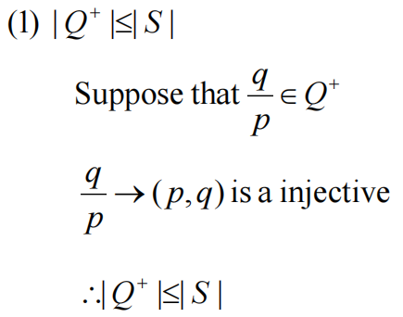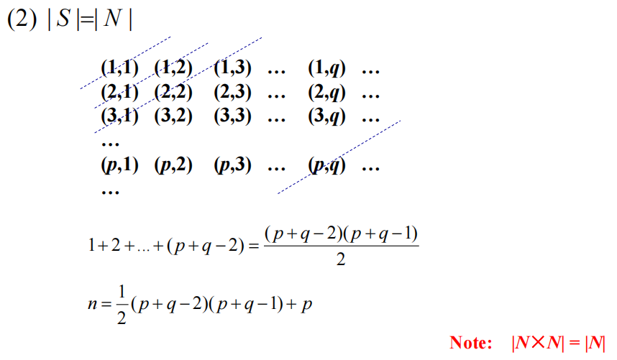

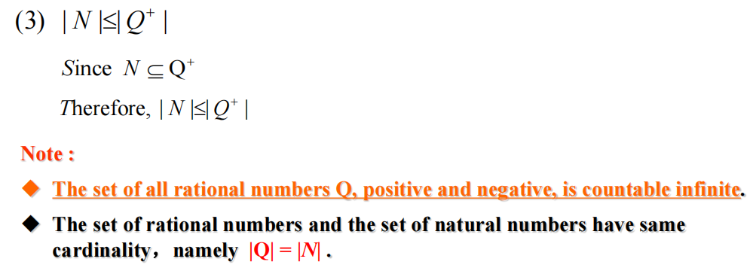

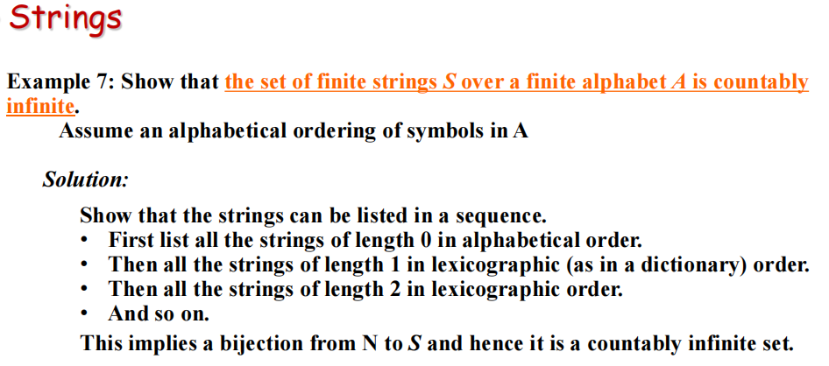

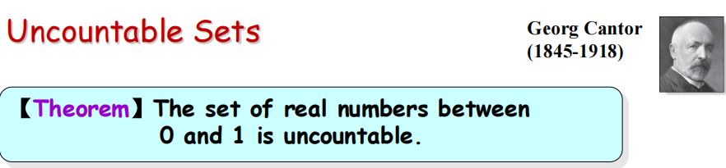

***Proof:***

***-* use an important proof method known as the Cantor diagonalization argument（康托对角线证明方法）.**

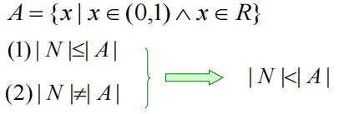

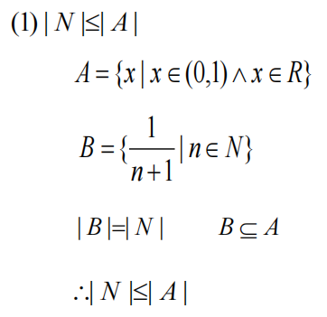

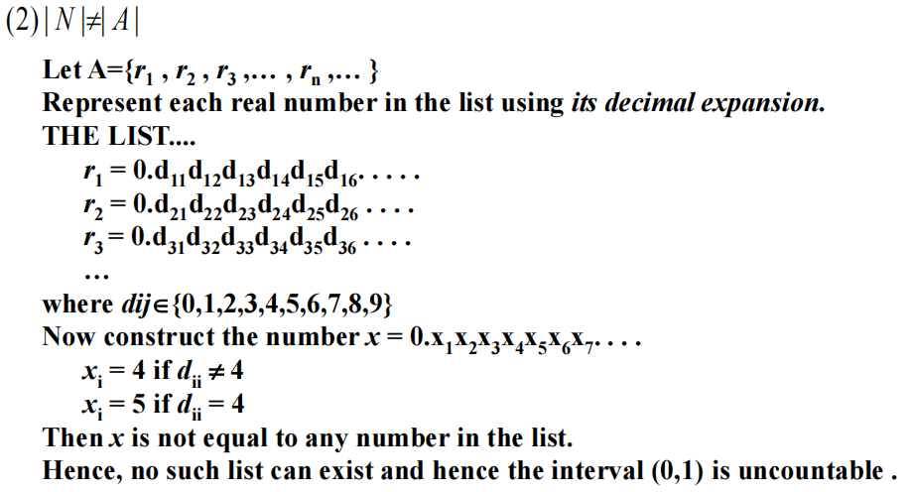

**证明|A|≤| B|的方法：**

1. **找一个一对一函数**
2. **证明A是B的子集**
3. **在B中找一个子集C，且|A|=|C|**

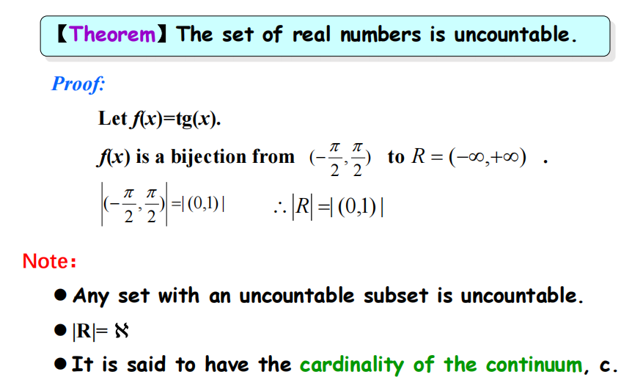

**cardinality of the continuum（连续体的基数）**

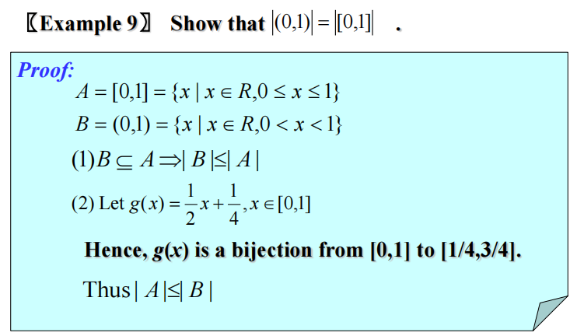

证明|A|=|B|的方法：

证明|A|<=|B|并且|B|<=|A|

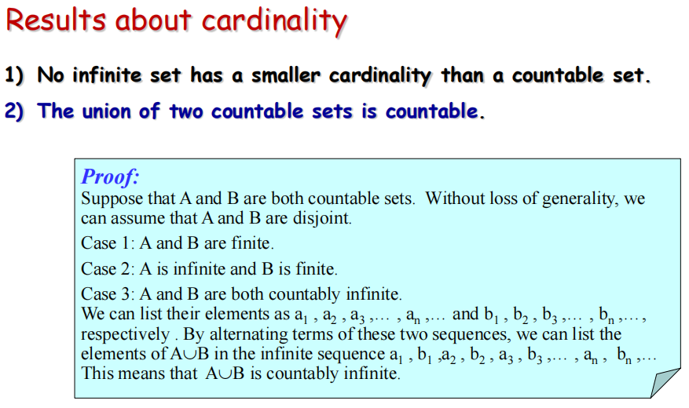

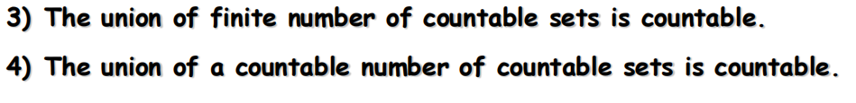

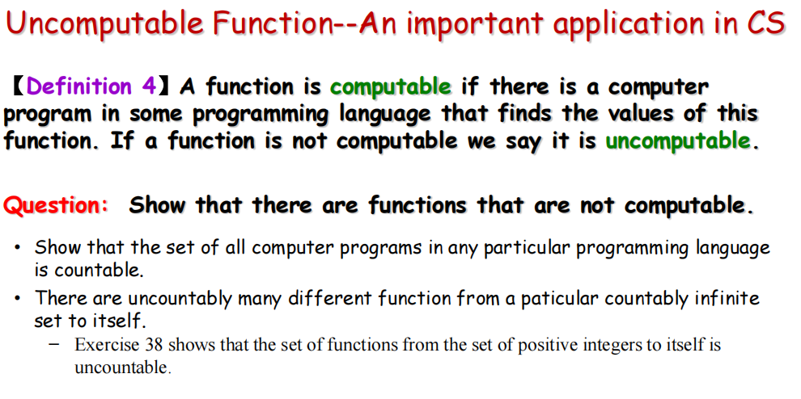

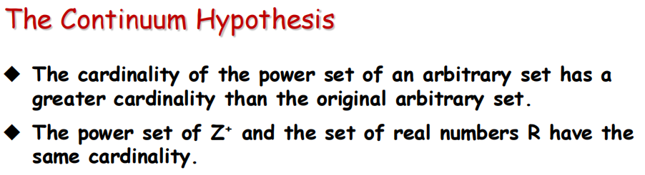

**|P(Z+)|=|R|= c**



**（2.6）Matrices（矩阵）**

Section Summary

**Definition of a Matrix**

**Matrix Arithmetic（矩阵算术）**

**Transposes and Powers of Arithmetic（矩阵的转置和幂运算）**

**Zero-One matrices（零一矩阵）**

**Recursive(递归的)**